How to import scripts Into LogMeIn Rescue Technician Console

Please open LogMeIn Rescue Technician Console.

1. In the Console Status area, select **Tools** > **Manage Scripts**
2. Click Import.

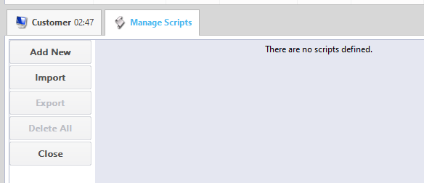

1. Select the file name LogMeIn Scripts1.0.xml then click Open. Get the file

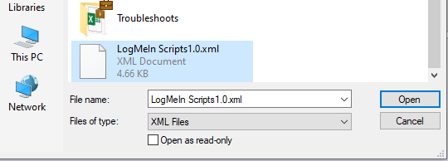

1. All scripts should be imported as seen below:

